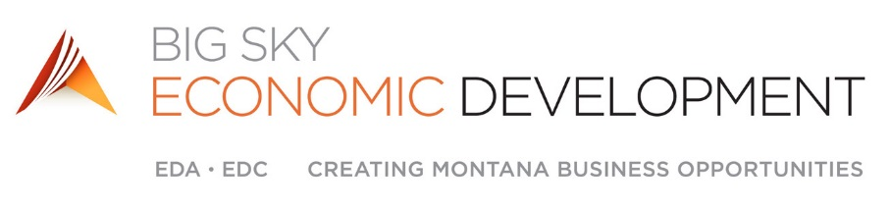

EDA/EDC Joint Board Minutes (Special Meeting)
Monday, March 23rd, 2020 – 3:30 P.M. – 4:30 P.M.
Zoom Teleconference Call
BIG SKY ED Mission Statement: - Focused on sustaining and growing our region’s vibrant economy and outstanding quality of life, Big Sky Economic Development provides leadership and resources for business creation, expansion, retention, new business recruitment and community development.

EDA Board Members Present: Bryce Terpstra, Dana Pulis, Greg McDonald, Jennifer Smith, Jennifer Owen, Ken Lutton, Paul Neutgens, Riley Bennett, Robin Rude, Shaun Brown (Ex-Officio), Katy Easton (Ex-Officio), John Brewer (Ex-Officio),

EDA Board Members Absent: George Warmer, Judi Powers, Don Jones (Ex-Officio), Greg Upham (Ex-Officio), Nick Altonaga (Ex-Officio)

EDC Board Members Present: Aaron Ramage, Ann Kosempa, Bob Wilmouth, Dave Ballard, David Ellis, Eric Simonsen, Kim Jakub, Mac Fogelsong, Mike Nelson, Mike Seppala, Scott Chesarek, Steve Loveless

EDC Board Members Absent: Andy Gott, Craig Bartholomew, Dan Edelman, Denis Pitman, Doug Hansen, Jon Stepanek, Mike Phillips, Mitch Goplen, Nicole Benge, Spencer Frederick

Staff and Guests: Evelyn Pyburn, Steve Arveschoug, Brandon Berger, Shanna Zier, Dustin Frost, Kevin Scharfe, Becky Rogers, Austin Trunkle, Dena Johnson, Lorene Hintz, Karen Miller, Dianne Lehm, Marcell Bruski, Johnna Jablonski

Call to Order:
Robin Rude, EDA Chair, called the meeting to order at 3:37 P.M.

Public Comment/Recognitions/Special Announcements and Introductions:
Public Comment
Steve opened the floor to Brent Donnelly, the Montana State Director of the Small Business Administration. Brent spoke about the effort at the federal level to release loan funds to business affected by the Covid-19 outbreak. Business owners are able to apply for up to $2M with an interest rate of 3.75%. Brent spoke about the high demand for aid and what may come of a proposed stimulus bill in Washington. There was also discussion about how soon these funds can be released.

Agenda Changes:
None

Consent Agenda
Approval of February Minutes, January Financials, and the EDC By-Laws revisions. These items were deferred during the regular March Board Meeting due to lack of quorum.

Approval of the Financials and Minutes

Motion: Mike Seppala to approve the February Minutes and January Financials, as presented to the Board.
Second: Paul Neutgens
Discussion: Above
Motion carried

Approval of the EDC By-Laws Revisions

Motion: Mike Seppala to approve the EDC By-Laws revisions as presented to the Board.
Second: Dave Ballard
Discussion: Above
Motion carried

Program Level Reports and Action Items
Economic Injury Survey Summary – Steve
Steve continued by providing an update to the Board regarding businesses who have filled out an economic injury worksheet.

Of the 196 completed sheets, revenues were estimated to have been $24M at this time last year. Survey respondents are now estimating revenues to be $8.8M in light of the shutdowns.

The amount of employees at this time last year were estimated to be 3,545, but are now reported at 1,316.

Steve went on to mention the letter sent out by the Montana Economic Developers Association. MEDA held a call last week to speak about tools our business communities need. Senator Daines, Congressman Gianforte, Lieutenant Governor Mike Cooney, and Pam Haxby-Coate of Senator Tester’s Office joined the call.

Operations Update
BSED has made some changes in light of the social distancing measures. We have adopted a work from home option for our staff and have been using teleconferencing options for staff meetings and other regular meetings. We have also expanded our sick leave policy to support employees who are now obligated at home to take care of their children while school is out.

Member Investor Program Update – Melanie
Melanie updated on the 2020 Board Member Challenge. Mel has about 70 potential prospects on the list and considers half of those in the “High Possibility” category.

The goal is to have 30 new member investors for our 30th anniversary. Scott Chesarek will be treating everyone who participates to lunch.

BSF Finance Short-Term Loan Program –Brandon/Dena
Dena began by answering how we arrived at the idea of providing a short-term loan program to help companies stay afloat amid lay-offs and drastically reduced revenues.

Brandon explained that in 2010, the Treasury granted money to states to lend to small businesses in need. The State Small Business Credit Initiative that BSED manages has loaned more than $2m and has about $1m it can still use. Brandon is asking the Board to authorize $250,000 from that fund to lend to businesses affected by the shutdowns. One of the conditions of offering this financing would be that those applying must also have applied for the SBA disaster loans. The maximum amount we would lend to a business owner would be $15,000. Brandon continued to review the specific criteria, lending scenarios, and terms of the loans. The funds can be used as working capital and we anticipate most will use it to cover short term needs. Brandon also mentioned that Big Sky Finance and the Revolving Loan Fund borrowers have reached out about deferred payments. Brandon is asking the Board to authorize an internal team to review and underwrite these loans. Brandon continued to list eligibility requirements for borrowers and what we will consider in reviewing applications. To expedite the application and review process, the team will be using DocuSign and Survey Monkey to approve applicants. There was also discussion about how the team arrived at an interest rate of 2%. Brandon and Dena fielded additional questions and considerations from the Board.

Motion: Mike Seppala to approve the BSF Short-term Loan Program and release of SSBCI funds, as presented to the Board.
Second: Mac Fogelsong
Discussion: Above
Motion carried

Brandon mentioned that BSF has already received 19 requests for payment deferments. BSF cash flow should not be affected.

PTAC Base Year Approval - Deanna
Deanna began explaining that this is a new base year for the PTAC with subsequent option years to follow. The application does not obligate BSED and is a usual step in the process.

Motion: Jennifer Smith to approve the PTAC Base Year Application, as presented to the Board.
Second: Riley Bennett
Discussion: Above
Motion carried

Better Off in Billings Update – Melanie
Melanie gave a quick Better Off in Billings update. The physical event has been cancelled but there is alternate planning ongoing and the keynote has been rescheduled to later in the year. The Space2Place micro-grant program will continue as scheduled and applicants are currently being reviewed.

Public Comment
Steve is working with Shanna to review our operational budget and what FY2021 will look like. Several moving pieces are being considered, including loan origination and servicing fees and Member Investor revenues.

Adjourn
Robin Rude Adjourned the meeting at 4:37 PM

Next Meeting – April 9th, 2020

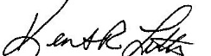
Respectfully submitted,

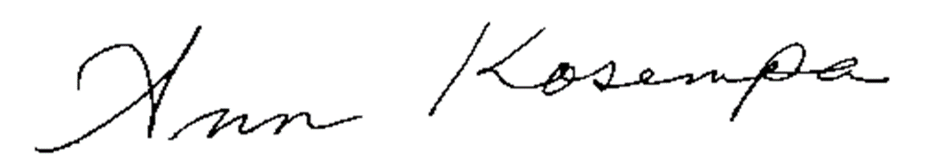
______________________________________ _____________________________________
Ken Lutton, EDA Secretary/Treasurer Ann Kosempa, EDC Secretary/Treasurer

When approved, minutes and meeting materials will be filed electronically in the Big Sky EDA office.
Big Sky Economic Development Board of Directors will make reasonable accommodations for known disabilities that may interfere with an individual’s ability to participate. Persons requiring such accommodations should make their requests to Big Sky Economic Development as soon as possible before the meeting day. Please call Big Sky ED at 256-6871.

